1. Design a Login Form with username and password using LinearLayout and toast valid credentials
2. <?xml version="1.0" encoding="utf-8"?>  
     
   <LinearLayout xmlns:android="http://schemas.android.com/apk/res/android"  
    android:orientation="vertical" android:layout_width="match_parent"  
    android:layout_height="match_parent">  
    <TextView  
    android:id="@+id/loginscrn"  
    android:layout_width="wrap_content"  
    android:layout_height="wrap_content"  
    android:layout_marginTop="80dp"  
    android:text="Login"  
    android:textSize="25dp"  
    android:textStyle="bold"  
    android:layout_gravity="center"/>  
    <TextView  
    android:id="@+id/fstTxt"  
    android:layout_width="wrap_content"  
    android:layout_height="wrap_content"  
    android:layout_marginLeft="100dp"  
    android:layout_marginTop="20dp"  
    android:text="Email"/>  
    <EditText  
    android:id="@+id/txtEmail"  
    android:layout_width="wrap_content"  
    android:layout_height="wrap_content"  
    android:layout_marginLeft="100dp"  
    android:ems="10"/>  
    <TextView  
    android:id="@+id/secTxt"  
    android:layout_width="wrap_content"  
    android:layout_height="wrap_content"  
    android:text="Password"  
    android:layout_marginLeft="100dp" />  
    <EditText  
    android:id="@+id/txtPwd"  
    android:layout_width="wrap_content"  
    android:layout_height="wrap_content"  
    android:layout_marginLeft="100dp"  
    android:inputType="textPassword"  
    android:ems="10" />  
    <Button  
    android:id="@+id/btnLogin"  
    android:layout_width="wrap_content"  
    android:layout_height="wrap_content"  
    android:layout_marginLeft="100dp"  
    android:text="Login" />  
   </LinearLayout>

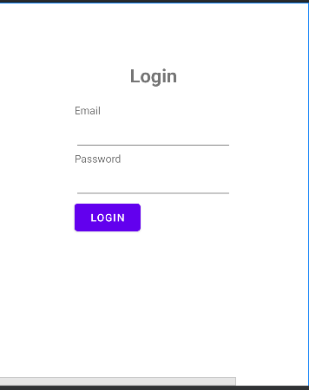

2)Functions

java

package com.example.lab;  
  
import androidx.appcompat.app.AppCompatActivity;  
  
import android.os.Bundle;  
import android.util.Log;  
  
public class MainActivity extends AppCompatActivity {  
  
 @Override  
 protected void onCreate(Bundle savedInstanceState) {  
 super.onCreate(savedInstanceState);  
 setContentView(R.layout.*activity_main*);  
 Log.*d*("lifecycle","onCretate invoked");  
 }  
 @Override  
 protected void onStart() {  
 super.onStart();  
 Log.*d*("lifecycle","onStart invoked");  
 }  
 @Override  
 protected void onResume() {  
 super.onResume();  
 Log.*d*("lifecycle","onResume invoked");  
 }  
 @Override  
 protected void onPause() {  
 super.onPause();  
 Log.*d*("lifecycle","onPausw invoked");  
 }  
 @Override  
 protected void onStop() {  
 super.onStop();  
 Log.*d*("lifecycle","onStop invoked");  
 }  
 @Override  
 protected void onRestart() {  
 super.onRestart();  
 Log.*d*("lifecycle","onRestart invoked");  
 }  
 @Override  
 protected void onDestroy() {  
 super.onDestroy();  
 Log.*d*("lifecycle","onDestroy invoked");  
 }  
}

